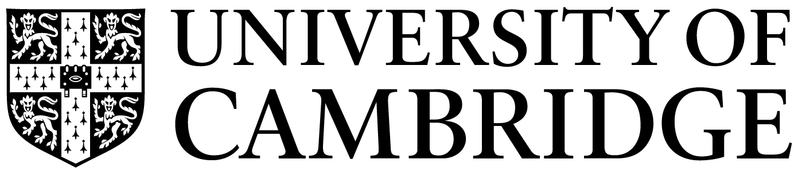
Dr. Edoardo Gallo
University Lecturer
University of Cambridge
Queens’ College
Cambridge, CB3 9ET

Date: 09/08/2020

To CERF Board Members:

This is the report on progress for the “Monetary networks” project which I am pursuing during my CERF Fellowship.
We have completed the theoretical part of the project. The core element of the investigation consists of a lab experiment. The original plan was to conduct it at Chapman University (US) because it has one of the few laboratories worldwide that have the capacity to conduct experimental sessions involving 50 participants. Unfortunately, the lab is currently closed due to Covid-19 restrictions and it is unclear when it will open again. At the moment, we have decided to wait before exploring alternative routes (e.g. taking the experiment online).
I have presented the results of the work undertaken during my latest CERF tenure at invited seminars (University of Technology Sydney, Queensland University of Technology, University of Bologna, Paris School of Economics, University of Amsterdam, Université Paris 1 Panthéon-Sorbonne, University of Oxford, Cambridge-INET, Università Cattolica – Milan, University of East Anglia) and specialized workshops (BiNoMa Workshop on the Economics of Networks, SAET Conference).
Yours ever,
Edoardo Gallo

